Observer pattern
The FileUpdateMonitor.java and FileUpdateListener.java at src/main/java/org/jabref/model/util matches the Observer Design Pattern: The FileUpdateListener being the interface for the observer and the FileUpdateMonitor being the interface for a Subject. Should still note that in the implementation of the FileUpdateMonitor at src/main/java/org/jabref/gui/util/DefaultFileUpdateMonitor.java the implementation of the notifier also matches with the pattern.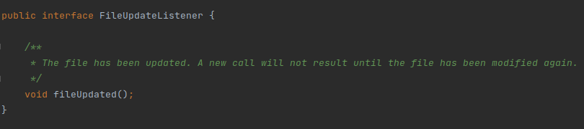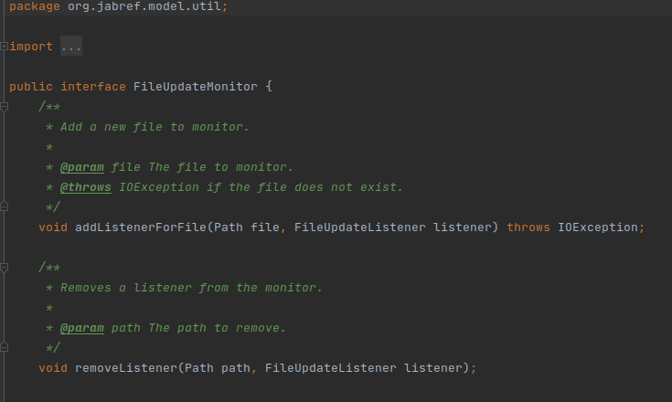

Factory pattern
The FieldFactory.java class at src/main/java/org/jabref/model/entry/field provides several different options for generating Sets of Fields:
